MAGNETIC CARD READING SYSTEM

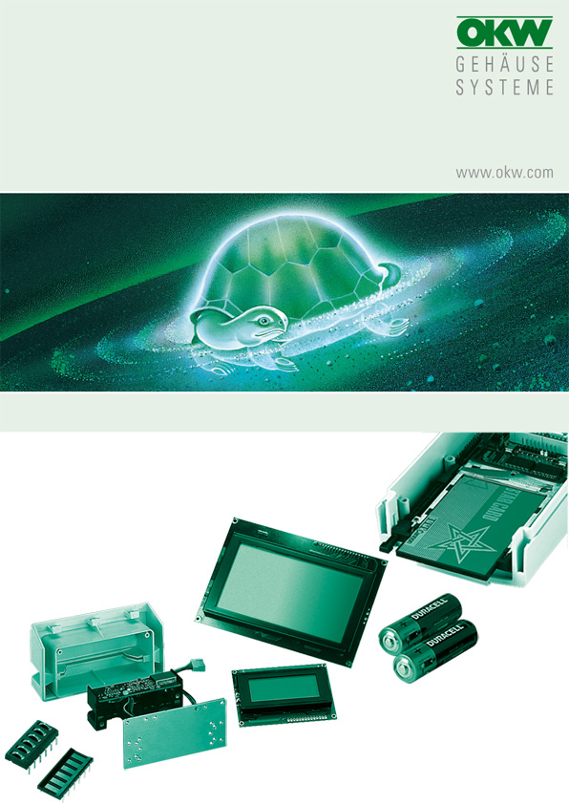

FOR DATEC-TERMINAL L (B 40 30 917)

All of the magnetic card reading systems shown in the list can be built into the lid with a slot. When ordering, please specify the exact type designation so that the correct slots can be milled in the lid. The mounting plate Part-No. B4116136 is essential for the installation of the reader.

The screws for securing the reading systems to the mounting plate are not included in the scope of delivery.

Manufacturer |  | Source of supply |  | Type/ designation
OMRON Japan |  | CELCO electronic GmbH  Dr.-Schoenemann- Straße 40  D-66123 Saarbrücken  Phone +49 681 638083  Fax +49 681 638084 |  | all HNR...types  all HSR...types  all HBR...types  all HBR./S types
Hopt+Schuler Germany |  | DDM  Hopt+Schuler GmbH  Heerstraße 44  D-78628 Rottweil  Phone +49 741 26070  Fax +49 741 13398  ddm@hopt-schuler.com  www.hopt-schuler.com |  | 832 009  832 010
MAGTEK |  | Mag-Tek Europe  25-26 Shrivenham Hundred Business Park  Watchfield  Swindon SN6 8TZ  Phone +44 1793 786070  Fax +44 1793 786076  sales@magtek.co.uk  www.magtek.co.uk |  | 210450xx
PANASONIC Japan |  | DATA MODUL AG  Landsberger Straße 322  D-80687 München  Phone +49 89 56017 0  Fax +49 89 56017 119  info@data-modul.de  www.data-modul.de |  | ZU-M1121..20..  ZU-M1131..10..
KDE Inc. Korea |  | Trident Displays Netherlands  De Trompet 1703  NL-1967DB Heemskerk  Phone +31 251 2789 30  Fax +31 251 2789 40  sales@tridentdisplays.nl  www.tridentdisplays.nl |  | KT200 series

No responsibility is taken for the correctness of this information.

Odenwälder Kunststoffwerke
Gehäusesysteme GmbH
Friedrich-List-Str. 3
74722 Buchen/Germany
www.okw.com

